DATA ANALYTICS WITH TABLEAU

ASSIGNMENT-01

Name: DARAM LOWKYA Mail: [daramlowkya@gmail.com](mailto:daramlowkya@gmail.com)

College: Gudlavalleru Engineering College RollNo: 22481A5413

1.BAR CHART

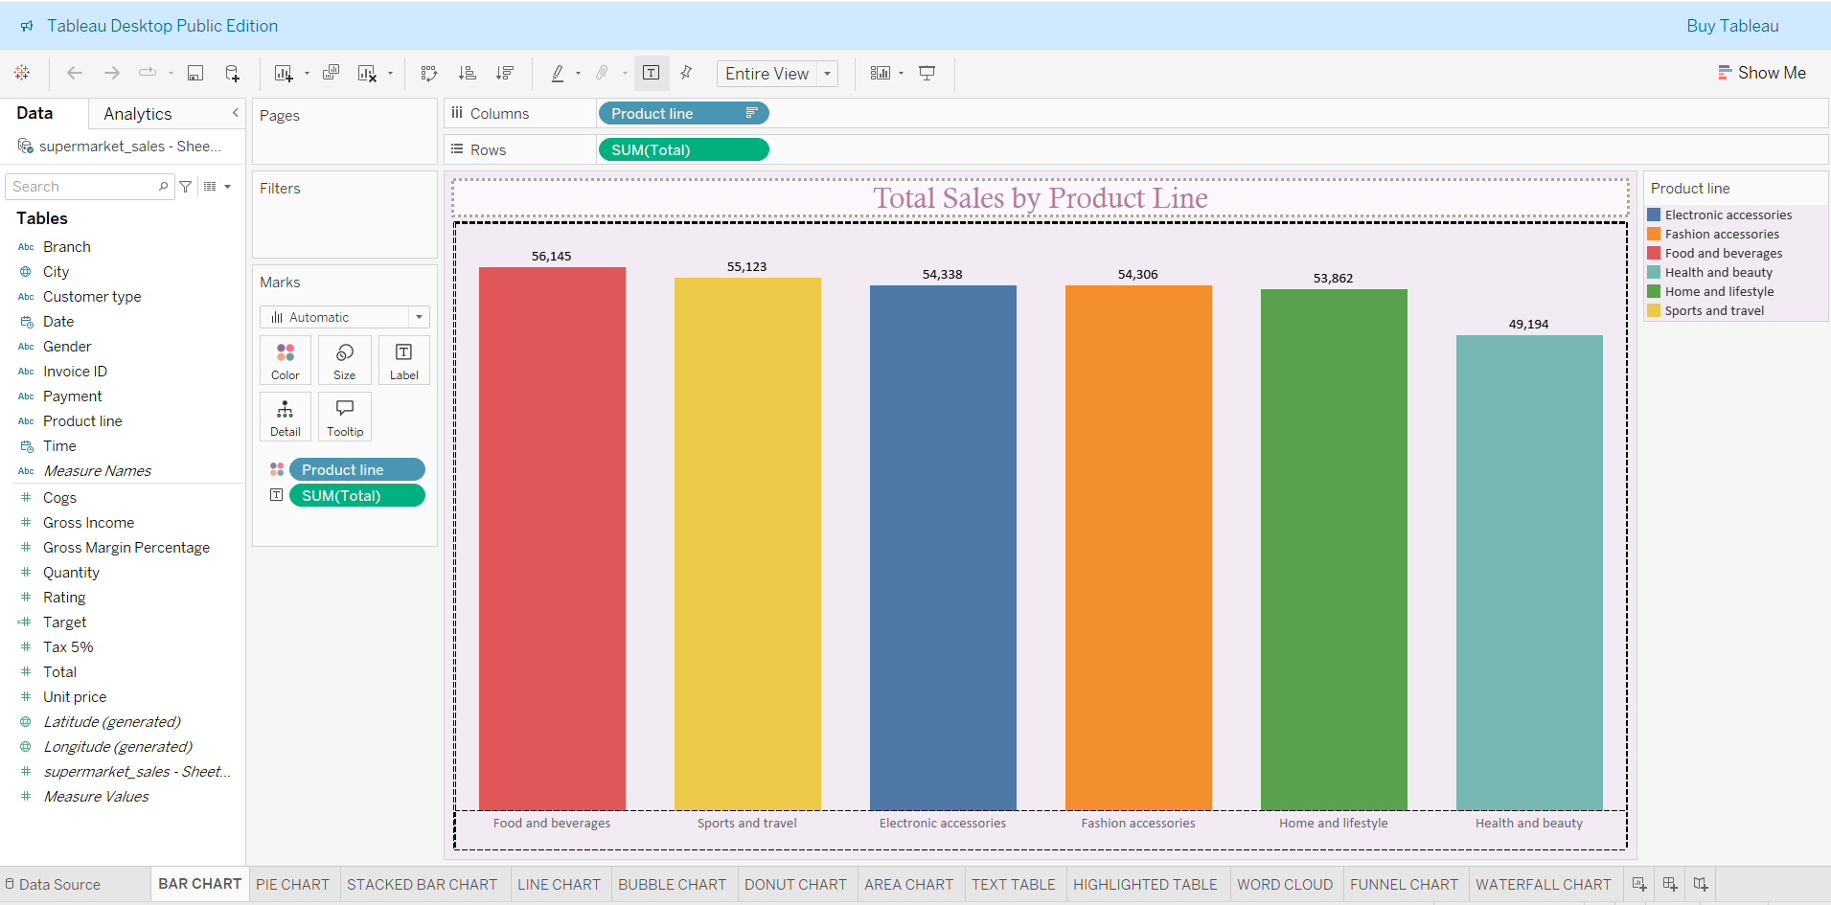

2.PIE CHART

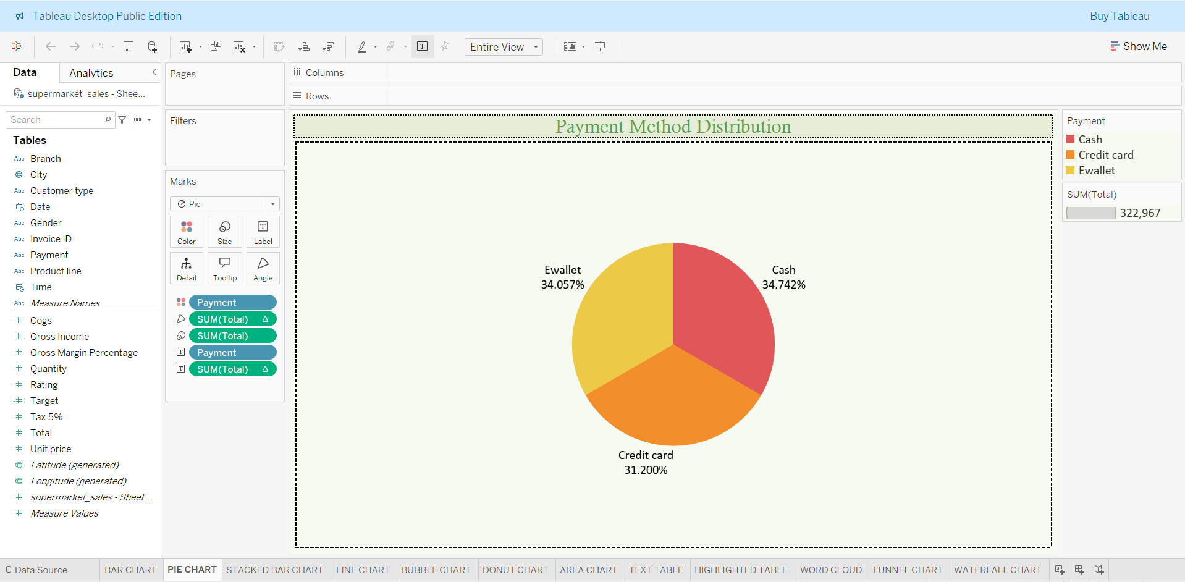

3.STACKED BAR CHART

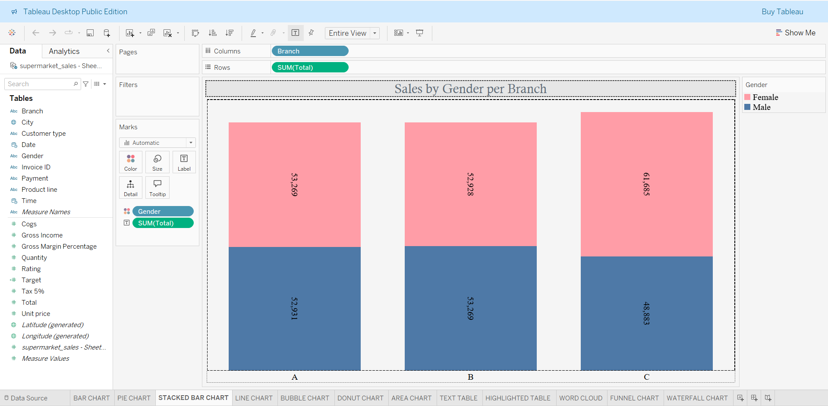

4.LINE CHART

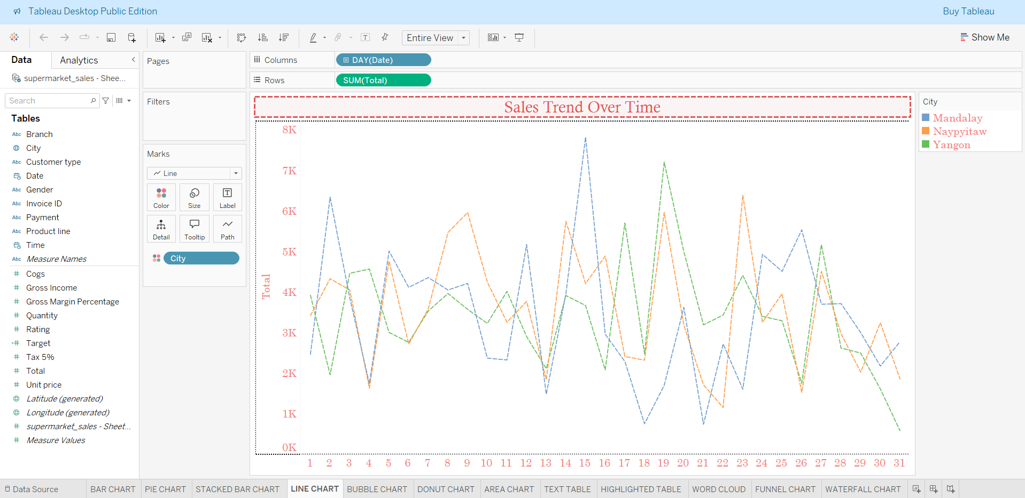

5.BUBBLE CHART

